PAST RATIO ANALYSIS QUESTIONS

**2019 - CALCULATE THE CURRENT RATIO AND THE ACID**

**TEST RATIO FOR BIOMED LTD FOR 2017 AND 2018.(B) ii**

**CA/CL**

2017 - 40,000:20,000 = 2:1

2018 - 62,500:25,000 = 2.5:1

**CA-Stock/CL**

40,000-10,000:20,000 = 1.5:1

62,500-42,500:25,000 = 0.8:1

**2019 – EXPLAIN WHAT IS MEANT BY A LIQUIDITY PROBLEM IN A BUSINESS. (B) i**

**A Liquidity problem refers to the inability of a business to raise funds to pay short term debts as they fall due.**

**2019 - DECREASE IN SALES HAS ON A BUSINESS (A)**

1. Reduction in profits
2. Restructuring of costs required
3. Employee numbers may have to be reduced
4. Sales Promotions may need to be increased
5. Identify alternative suppliers
6. Product modifications
7. Market Research – new markets required.

**2018 - OUTLINE TWO PROBLEMS CAUSED BY INSUFFICIENT WORKING CAPITAL FOR A START-UP BUSINESS**

1. Objectives of the business cannot be achieved

affects the liquidity position

1. Short term liabilities cannot be met on time
2. Business opportunities like cash discount and trade discount cannot be availed
3. The business may be overtrading

**2019 – ANALYSE THE SIGNIFICANCE OF THE TRENDS FOR THE LIQUIDITY OF BIOMED LTD (B) iii**

1. The current ratio increased from 2:1 to 2:5:1. This is above the ideal ratio of 2:1.
2. The acid test has decreased from 1.5:1 to 0.8:1 This is below the ideal of 1:1.
3. The business is carrying too much stock in its current assets. This may result in a difficulty in raising cash to pay short term debts, as stock can take time to sell.

**2018 – EXPLAIN THE TERM WORKING CAPITAL.**

The level of cash available for the **day by day** running of a business/ the level of cash available to run the business in the **short run**/It is used to **pay current liabilities** such as creditors, bank overdraft, accruals/Working Capital is **calculated by subtracting current liabilities from current assets.**

**2017 – ANALYSE THE PROFITABILITY AND LIQUIDITY OF EQUINOX DESIGN (C) i**

**Profitability**

1. The Net Profit Margin (NPM) has decreased from 20.5% to 15.2%
2. The Return on Investment (ROI) has decreased from 8% to 4%.
3. Analysis of trends: NPM: A major review of its costs will be required as well as a review of its sales strategy/seek cheaper raw materials/increase selling prices.
4. This decrease in ROI (profitability) will concern the shareholders of the business, as they may get a better return for their investment **e**

**2017 – CALCULATE THE FOLLOWING FOR EQUINOX DESIGN (B) iii & iv**

**MUST SHOW FORMULA**

**Return on investment Debt Equity**

Net Profit x100 Debt:Equity

Capital Employed

30,400 x 100 400,000: (300,000+60,000)

300,000+400,000+60,000

4% 1.1:1

**2017 – CALCULATE THE FOLLOWING FOR EQUINOX DESIGN (B) i & ii**

**MUST SHOW FORMULA**

**Net Profit Margin Current Ratio**

Net Profit x 100 Current Assets: Current Liabilities

Sales

30,400 x 100 20,000:16,000

200,000

15.2% 1.25:1

**2017 – ANALYSE THE PROFITABILITY AND LIQUIDITY OF EQUINOX DESIGN (C) i**

**Liquidity**

The Current Ratio has decreased from 2:1 to 1.25:1

Analysis of trend: This is unsatisfactory for the business as while still having enough to pay their short term debts, liquidity has declined. This will be of concern to suppliers/could sell off slow moving lines to improve liquidity etc.

**2017 - SHOULD EQUINOX DESIGN LTD EXPAND ITS BUSINESS? (C) ii**

No.

The business should not expand as all key financial indicators are in decline

**2017 – OUTLINE TWO LIMITATIONS OF USING RATIOS (C) iii**

1. Staff relations with Management not taken into account
2. Assets may not be shown at their true value.
3. Ratios are based on past figures and not on projected
4. Final Accounts only hold for a certain year/Balance Sheets are only true for the day they are written.
5. Does not consider business environment i.e. Competition
6. Different accounting policies may be used from one year to

The next

PAST MANAGEMENT SKILLS QUESTIONS

**2015 – CALCULATE THE NET PROFIT PERCENTAGE**

**(MARGIN) (i)**

Net profit/Sales X 100

Gross Profit 22,000

– Expenses 12,000

= Net Profit of €10,000 = 10,000 / 50,000 = 20%

**2016 - IS LALCO LTD. A HIGHLY GEARED OR LOWLY GEARED (ii)**

Lalco Ltd. is highly geared – this means the firm has to make high interest payments resulting in low/no dividend payments to shareholders. Assets may be used as security/Capital repayment required/May impact on ability to borrow in the near future/Impact on the firm’s profits/cash flow.

**2016 – USING THE FIGURES BELOW, CALCULATE THE DEBT/EQUITY RATIO (GEARING) (i)**

Debt Capital: Equity Capital

700,000:220,000 + 130,000

700,000:350,000

2:1

**2015 – HOW MANAGEMENT COULD USE THIS INFORMATION (ii)**

The Net Margin has fallen by 5% showing that the firm’s profitability has decreased and that it may be time for management to control its costs by deciding for example to cut wages, source cheaper raw materials or it should try to increase sales revenue.

**2014 - CALCULATE THE DEBT/EQUITY RATIO FOR 2013 (B) ii**

Debt: Equity

200,000 : 450,000 + 150,000

200,000 : 600,000

.33 : 1

**2014 – EXPLAIN THE TERM 'DEBT/EQUITY RATIO'. (B) i**

The debt/equity ratio is an analysis of the capital structure of the business. It indicates what proportion of capital is made up of long term loans and what proportion of capital is made up of reserves and issued ordinary share capital**.**

**2014 – IMPORTANCE OF THE DEBT/EQUITY RATIO IN DECIDING ON NEW SOURCES OF FINANCE (B) iii**

Flame Ltd is a lowly geared company which means the majority of the capital has been provided by the owners in the form of share capital and retained earnings. Flame Ltd can raise further capital by selling shares up to a limit of €450,000 (Authorised – Issued). Raising finance through additional loans is an option for Flame Ltd because it does not have too many existing loans already, as it is lowly geared.

**2013 – COMMENT ON THE LIQUIDITY POSITION OF SENTRY LTD (B)**

1. Sentry Ltd has not managed to attain the recommended current ratio of 2:1.
2. Sentry Ltd is not liquid and is overtrading i.e. it cannot pay its debts as they arise.
3. Sentry Ltd will have difficulty in raising cash quickly and paying its bills as they fall due.

**2013 – CALCULATE THE CURRENT RATIO (A)**

Current Ratio is CA: CL

CA 12000 + 15000 + 8000 = €35000

CL 20000 + 50000 = €70000

Current Ratio = €35,000: €70,000

0.5:1

**PROFIT AND LOSS ACCOUNT AND BALANCE SHEET**

**BALANCE SHEET**

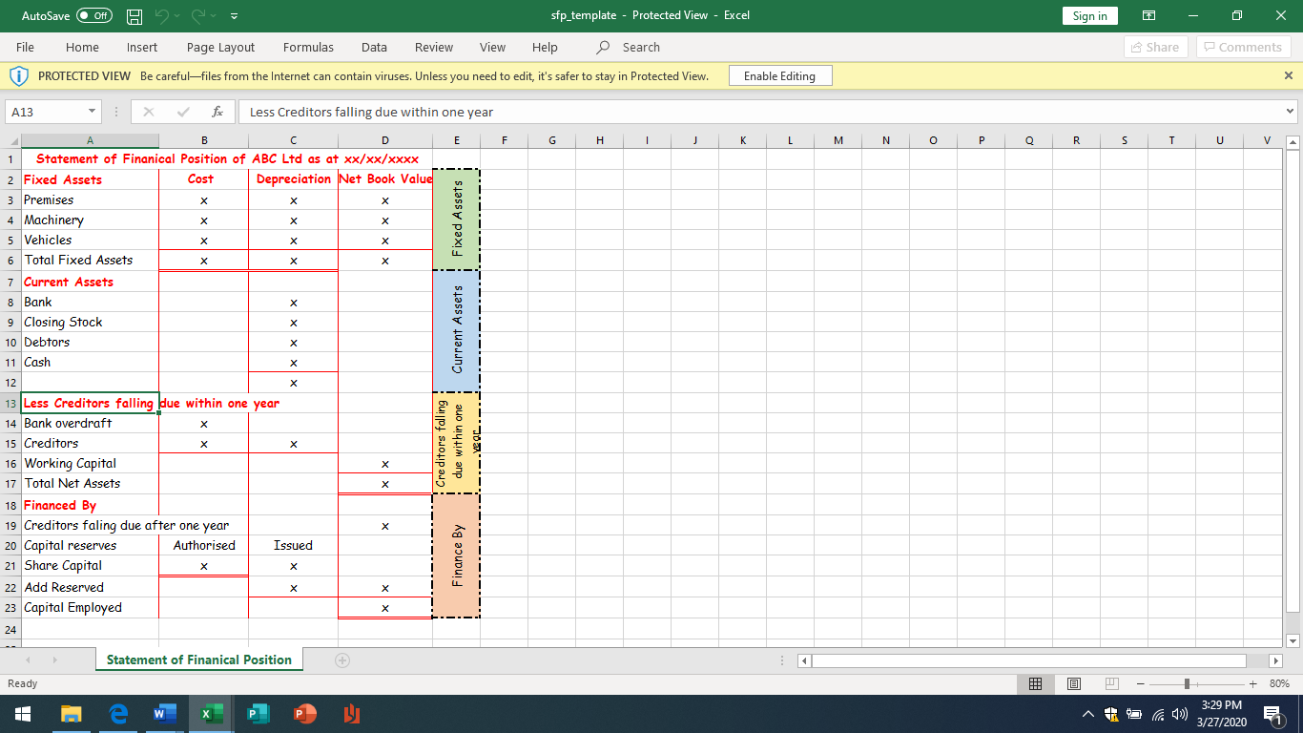

**PROFIT AND LOSS ACCOUNT**

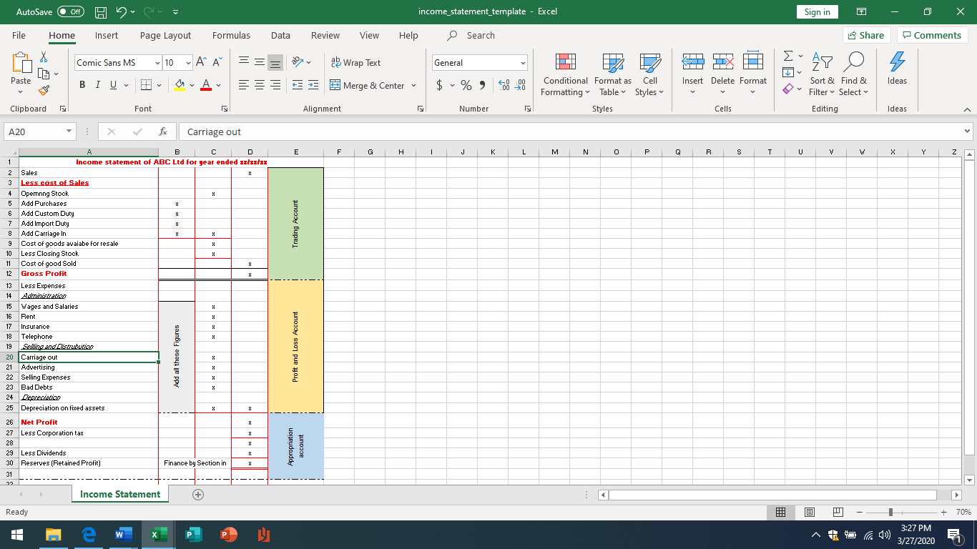

**Key Words**

**Cost of sales -** This is the cost of purchasing or making the product (Raw

materials, purchases stock)

**Gross profit -** This is the profit before any expenses, interest are deducted**.** Low gross profit indicated that the cost of raw materials are too high or the selling price is not high enough

**Expenses -** These included items such as Rent, wages, Electricity, Light and heat

**Net Profit -** This is the profit after expenses are deducted**.** A low net profit indicated that the business expenses are too high

**Corporation Tax** - This is tax that is paid by companies on their profits

**Dividends** - This is a share of the profits that are paid to the shareholders

**Retained earnings -** This is the profits that is left after all the expenses,

cost and dividends

have been taken out (It is an important source of long-term finance)

**Fixed Assets** - Theses are permanent items owned by the business. They can

be tangible – they can be seen or touched (Building) or intangible – They can’t

be seen (Good Will). Fixed assets show a bank how much security a business

has when they are applying for a loan

**Current Assets** - These are assets that are always changing during the year. And Included Debtors who are people who owe the business money

**Current Liabilities** These are debts that should be paid within one year. The included Creditors who are the people the business owe money too

**Working Capital**- This is the finance that is used for the day to day running of a business. It is usually gotten by subtracting the current assets figure from the current liabilities figure. It shows if the business has enough money to pay their short term debts

**Finance By** - This section shows the source of long term finance that is raised by a business. It included ordinary shared, preference shares, Debentures and loans. It shows the borrowing in a business and if they can borrow more

**Ordinary shares** - This is the value of share that have been issued to shareholders

Equity capital This is the amount of funds that are owned by the shareholders

**Capital Employed** - This is the total finance that the company used in a year

**WHAT IS THE PROFIT AND LOSS ACCOUNT?**

A profit and loss (P&L) account shows the amount of income earned, expense incurred, and profit made by the business. It also shows

1. How much profit was paid out in tax
2. How much was paid in dividends
3. How much was retained in the business for the future

**WHAT IS THE BALANCE SHEET?**

This is a statement of the wealth of a business. It shows all the assets (something the business owns) and liabilities (Owes) by the business at a specific date

**RATIOS**

**GEARING**

|  |
| --- |
| **Current Ratio** |
| Debt Capital  Equity Capital |
| 1. This ratio shows the capital structure of the business and its ability to repay long term debts. |
| **Lowly Geared** – Equity > debt usually less than 1 or 100%  **Neutral Geared** – 1 or 100%  **Highly Geared** – Debt higher that equity usually higher that 1 or 100% |

**LIQUIDITY**

|  |  |
| --- | --- |
| **Current Ratio** | **Acid Test Ratio** |
| Current Assets  Current Liabilities | Current Assets – Closing stock  Current Liabilities |
| 1. This is also known as the Working Capital Ratio. 2. The Ideal Ration here is to have 2:1. 3. This means that for every 1 Liability we owe we have 2 Assets to pay for it 4. or for every €1 we own we have €2 to pay. This means that we can repay our debts and still have money in the business | 1. This is also known as the Quick Ratio. 2. The Ideal Ration here is to have 1:1. 3. This means that for every 1 Liability we owe we have 1 Assets to pay for it 4. or for every €1 we own we have €1 to pay. This means that we can repay our debts and still have closing stock left over to sell. |

**PROFITABILITY**

|  |  |  |
| --- | --- | --- |
| **Gross Profit Margin** | **Net Profit Margin** | **Return on Capital Employed** |
| Gross Profit X 100  Sales 1 | Net Profit X 100  Sales 1 | Net Profit X 100  Capital Employed 1 |
| 1. It shows the amount of Gross Profit the company will get from Sales. 2. For example, a Gross Margin of 45% means that the business is earning 45c Gross Profit. 3. The higher the Gross Profit the easier the business can pay its expenses | 1. It shows the amount of Net Profit the company will get from sales. 2. For example, a Net Margin of 20% means that the business is earning 20c Net Profit. 3. The higher the Net Profit Margin the higher the profits. | 1. This figure measures the firm’s ability to generate profits from the money invested in the business. 2. It shows the return the investor will get for the money the give to the business. The higher the ROI the better |
| a decline in this ratio is due to  Increased cost of Sales – This can be due to higher material or production costs  Lower profit This is because the selling price is low | A decline in the net profit margin is due to an increase in the expenses |  |

**WHAT THE LIQUIDITY RATIO TELLS US ABOUT THE BUSINESS**

1. Liquidity – This is the firm’s ability to repay back it’s debts. If liquidity is too low the business will not be able to repay its debt on time and might go out of business
2. Insolvency – This occurs when the liabilities (Debt) is higher that the Assets. This means that the business can’t pay its debts back. This is very serious and can result liquidation
3. Liquidation – is when a business is closed, and their assets are sold off. The money raise is used to pay the creditors

**WHY STAKEHOLDERS ARE INTERESTED IN MONOTORING A BUSIENSS**

Managers – Help with decision and how well the business is performing

Investors – How risky the business is, the ability to make a profit and the return they will get

Employees – If they will have a job, use to seek a wage increase

Banks – Ability to repay a loan, looking at the liquidity ratios

Suppliers – Ability to pay for supplies given on credit

Government – The Tax to be paid

**HIGH GEARING CAB CAUSE THE FOLLOWING PROBLEMS**

1. Greater pressure on Management – To increase profits to repay the interest
2. Reduced dividends – Payments of Preference share and debenture loan get paid before first
3. Difficulty raising finance – Less likely to pay dividends and therefore more risky
4. Difficulty raising loan finance – Bank will have doubts in the firm’s ability to pay back loans
5. Risk of Liquidation – risk interest rate ore not paid on time

**HOW TO MANAGE THE WORKING CAPITLA IN A BUSIENSS**

It is very important that all business manage their working capital so they can pay back their debts. To Help with this firms can do the following

1. Sell of slow-moving stock – this will result in the company getting cash
2. Proper stock control – This will reduce the amount of money that the company has tied up in stock and free up storage
3. Credit Control – Monitor which customers to give credit to and for how long. Effective credit control and reduce bad debts
4. Increase prices – This will increase the profit margin
5. Raise more finance – This can be done by selling shares, getting a loan or selling off assets
6. Prepare Cashflow forecasts – This will help to identify money problems and to put in measure against it (get a Loan). It will also show the money going in and out of the business.