PAST MANAGING CHANGE QUESTIONS

**2015 – (ABQ) EVALUATE THE EFFECTIVENESS OF THE APPROACH TAKEN TO ADAPT TO CHANGE.**

Communication/ Consultation

Negotiation

Rewards

Facilitator: Management

Empowerment

Training and Development

Adequate Funding/Resource provider

**2015 – OUTLINE YOUR UNDERSTANDING OF STORMING AND NORMING.**

Storming: Team members test relationships and tensions/Conflicts frequently arise/Members try to establish their positions on a team/Members may act as individuals and resist other views/Differences are challenged.

Norming : Constructive relationships and ways of working together emerge/ Ground Rules and procedures are agreed and there is an increased focus on the task at hand/Greater sense of trust develops between team members.

**2016 - ANALYSE THE IMPACT OF NEW TECHNOLOGY ON BUSINESS COSTS AND ON BUSINESS OPPORTUNITIES**

**Impact on finance** financial cost of purchase; installing & maintenance costs (Loans) Cost

**Impact on production**- product quality & greater efficiency (CAD & CAM) (opportunity)

**Impact on staff** - staff redundancies; training costs; wider span of control; E-working; (opportunity)

**Impact on communications** - Quick/better decision making (e-mail) Opportunity

**Impact on marketing**-on-line advertising; on-line sales; Ecommerce (Website)

**Impact on sales**/enhanced reputation with existing/ potential customer;

**2011 - OUTLINE TWO STRATEGIES MANAGEMENT COULD USE TO HELP EMPLOYEES ADAPT TO CHANGE.**

Communicate

Consult

Reward employees

Employee empowerment

Total Quality Management (TQM)

Training,

Teamwork

**2012 - DISCUSS THE BENEFITS AND RISKS OF EMPOWERING EMPLOYEES WITHIN A BUSINESS.**

**Benefits**

1. Decision-making and control is in the hands of employees who use their greater skills and knowledge for the benefit of the business

2. Employees become more responsive to the needs of customers/come up with ideas to solve issues/more satisfied customers.

3. Employees more motivated/job satisfaction/valued/improved morale/loyal.

4. Employees are better prepared for promotion/better trained.

5. Management can focus on strategic planning.

**2012 - DISCUSS THE BENEFITS AND RISKS OF EMPOWERING EMPLOYEES WITHIN A BUSINESS.**

**Risks**

1. If introduced without adequate training then mistakes can be made.

2. Employees may be unhappy with the extra responsibility and their stress levels may increase.

3. The lack of control and day-to-day supervision may encourage some empowered employees to take unnecessary risks,

4. Management are handing over control and power. Some managers may be cautious of this loss of control. can lead to conflict

**2006 – (ABQ) ADVISE ON THE STRATEGIES THAT WILL HELP MANAGE CHANGES**

1. Total commitment by senior management to the changes proposed

2. Genuine involvement and participation in the change process by

employees

3. Effective communications between all the parties throughout the change

4. Consultation with trade unions/employee representatives •

5. Adequate funding for all stages of the change process

6. Negotiation – remuneration packages, productivity agreements

7. Empowerment/Training/Job rotation/Job enlargement/Quality

**2008 – DESCRIBE TWO STRATEGIES THAT A BUSINESS ORGANISATION CAN USE TO MANAGE CHANGE.**

1. Senior Management commitment to the change process.

2. Effective Communication between all parties throughout the change process. This will reduce uncertainty and tensions.

3. Adequate funding for the proposed changes/training.

4. Negotiation – remuneration packages, productivity agreements, changes in work practices

5. Employee Empowerment/training/job rotation/job enlargement

6. Change in management style from ‘controller’ to ‘facilitator’.

• Funding/Rewards- Adequate funding for the change process/remuneration packages for staff.

**2011 – OUTLINE THE BENEFITS OF TEAMWORK FOR THE EMPLOYEES IN A BUSINESS.**

1. Greater job satisfaction

2. Communications skills and interpersonal skills improve

3. Tough decisions are easier for employees to make

4. Less industrial relations problems and less conflict,

**2003 – EMPOWERMENT HELPS A BUSINESS TO**

The empowerment of workers means placing real power, which includes decision-making and full responsibility, in the hands of those workers where it is most effective,

i.e. as close as possible to the customer. Empowerment means that managers who are not close to the customers give up control to those closest. Decision-making and control is in the hands of workers who use their skills in the interests of the organisation.

**2003 – DISCUSS THE BENEFITS OF TEAMWORK IN A BUSINESS ORGANISATION**

1. Individuals will feel a part of the organisation

2. Morale is high

3. Open communications encourage collaborative decision making

4. All conflicts are worked out through discussion

5. Employees enjoy their work more - part of a team structure.

6. Teams satisfy social needs in individual

7. Team goals and individual goals are shared

8. Teams support and help their members at difficult time

**2007 - EXPLAIN THE TERM TQM AND DESCRIBE HOW IT CAN BE OF BENEFIT TO AN ORGANISATION.**

TQM or Total Quality Management is a long-term focused effort

to change all parts of an organisation to produce the best

products or services for its customers. There are basically three

principles to a TQM approach: • Satisfying customer needs •

Providing to

PAST HUMAN RESOURCE MANAGEMENT QUESTIONS

**2007 - EXPLAIN THE TERM TQM AND DESCRIBE HOW IT CAN BE OF BENEFIT TO AN ORGANISATION.**

TQM of benefit to an organisation (describe):

1. Quality of products

2. Reduced costs

3. Staff motivation

4. Public image

5. Customer satisfaction

6. Productivity.

**MANAGE CHANGE**

**KEYWORDS**

**Employee Empowerment -** This means providing staff with a clear goal, deadline and sufficient resources and freedom to decide how to achieve a goal. It can boast self-esteem and self-actualization because staff have power and responsibilities.

**Teamwork** - Teamwork occurs when a group of people are working together towards a common goal. It empowers staff to have a direct say in how the business is run. Teams are self-managing which means they are responsible for running their own

**Forming -** The team is formed, and team members get to know one another

**Storming** - Team member disagree and argue about how to get the job done. The team leader must ensure that these are kept to a minimum

**Norming** - The team starts to establish ground rules for working effectively together in term of roles, responsibility, behavior and work methods

**Performing -** Once a team has settled down it should start to perform well with all members working together towards the team’s goals

**Total Quality Management (TQM) -** is an approach to management that aims to maximize quality by getting all staff involved in continuously looking for ways to improve the quality of a firms product and services.

**Electronic Data Interchange (EDI)** - This is an automated stock ordering system that allows orders to be place automatically from a computer in one business to a computer in another using the internet. It allows for oods to be ordered on time and the minimum of paper work

**Computer Aided Design (CAD)** - Is used to speed up product design

**Computer Aided Manufacture (CAM) -** Involves using computers to automate part of the work on an assembly line to reduce labour costs and improve quality

**Computer integrated manufacturing (CIM)** - Uses robots to control the entire production process from design and stock control to assembly and quality control. CIM can reduce labour costs but it must be managed carefully

**HOW TO MANAGE CHANGE**

**CAUSES OF CHANGE**

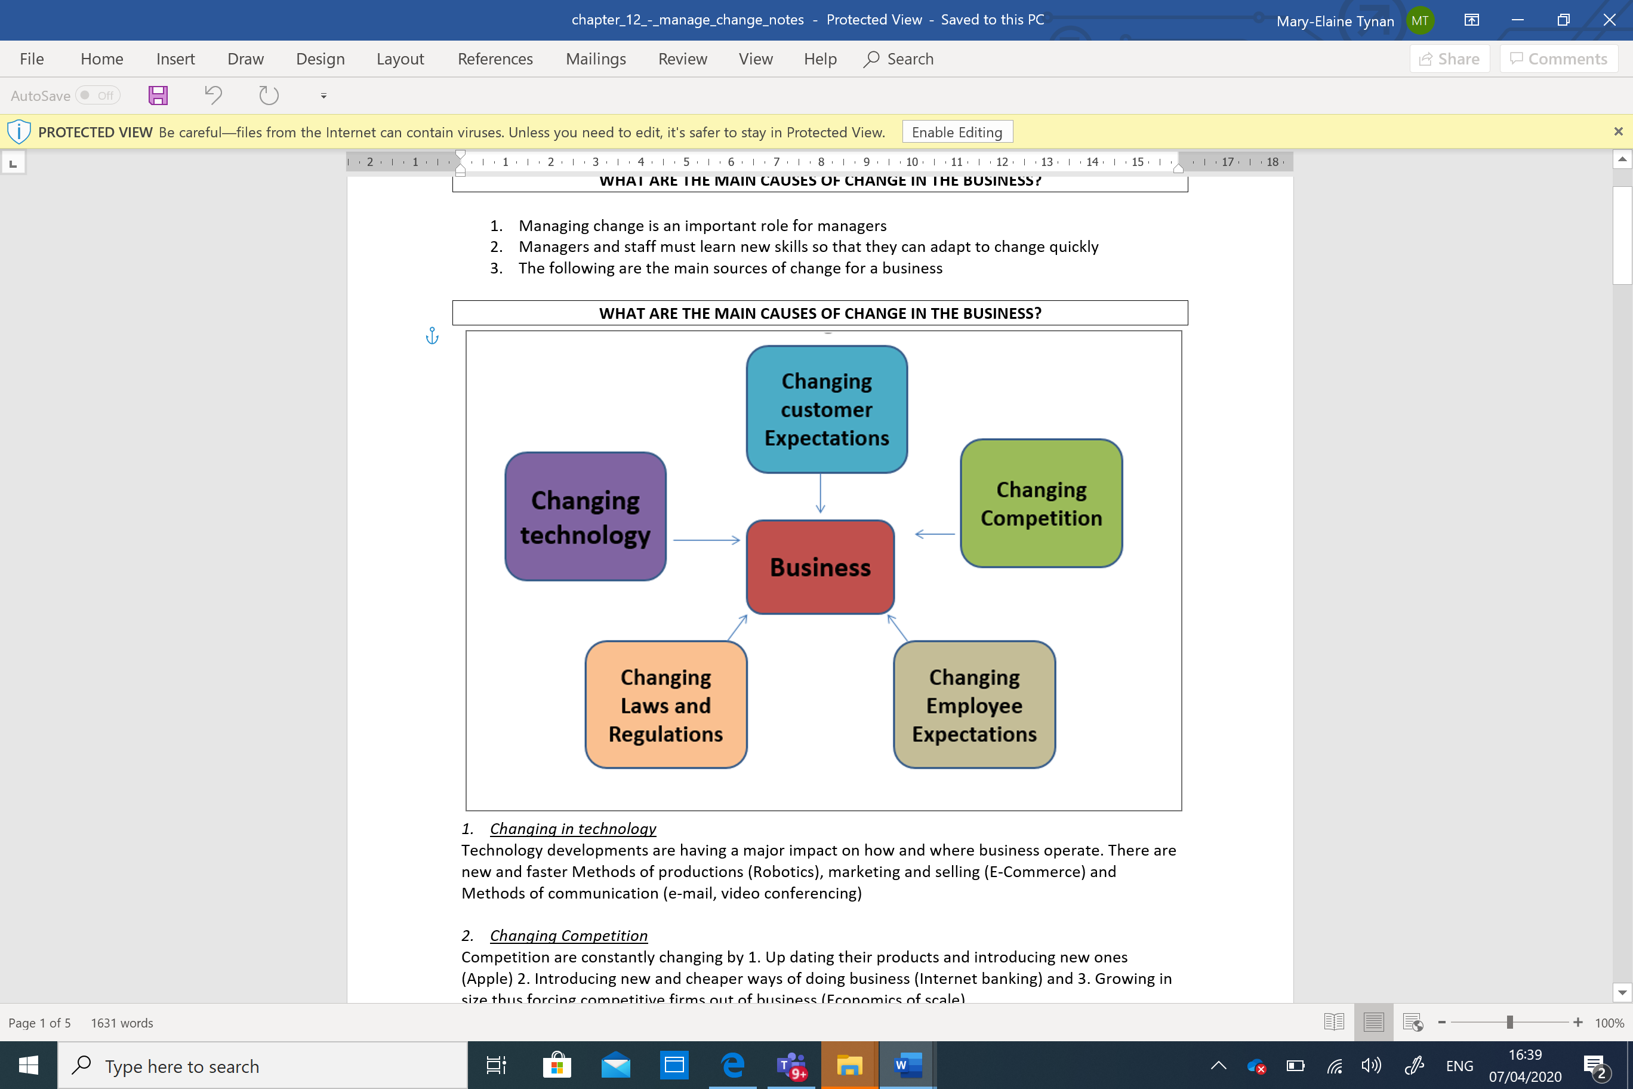

**COMMUNICATING THE NEED FOR CHANGE WITH STAFF**

Staff may not want change & become resistant. May be due

1. Changes may mean taking on extra work,

2.They may not be skilled to cope with the new changes,

3. They may lose their job (Or loss of income) and

4. the changes will not work (if there are too many of them)

To avoid resistant from employees’ managers should

**Communicate** - opening and honestly about the changes why they are important, what will happen no changes are made

**employee input** - into the decision making of the new changes. Staff who are involved are likely to co-operate

**Negotiating deals** - where necessary to provide fair rewards to the employees for scarifies they have made

**PROMOTE A ‘FACILITATOR’ MANAGEMENT STYLE**

Mangers must be able to trust their employees and allow then greater responsibilities and a say in the business decisions if change is to be successful.

This means becoming a ‘facilitative’ (democratic manger). This type of manger has a Theory Y approach resulting in staff being more co-operative.

Manager can become facilities by

1. Providing interesting and challenging work

2. Providing the training needed to do their job

3. Empowering staff to get on with the job

4. Mentoring staff by providing plenty of advice and support

5. Consulting regularly with staff about what work is to be done and the best way to do it

**BENEFITS AND DRAWBACKS OF EMPLOYEE EMPOWERMENT**

|  |  |
| --- | --- |
| **Benefits of Employee Empowerment** | **Problems with Employee Empowerment** |
| Increase creativity and staff Intrapreneurship | Serious mistake being made by staff |
| Reduced absenteeism | De-motivated staff who are unprepared for extra responsibilities |
| Increase job satisfaction | Unhappy middle managers who may feel that their decision-making powers are being taking away from them |
| Free up managers time |  |

**PROMOTE EMPLOYEE EMPOWERMENT**

This means providing staff with a clear goal, deadline and sufficient resources and freedom to decide how to achieve a goal. It can boast self-esteem and self-actualization because staff have power and responsibilities.

It requires the following

Managers to adapt a facilitator attitude

Investing in staff training

Proper management control - employee errors are quickly

Rewards to encourage staff (Financial and non financial)

* Teamwork

**MANAGE CHANGE**

**PROMOTE COMMITMENT TO QUALITY AMONG ALL STAFF (TQM)**

Total Quality Management (TQM) is an approach to management that aims to maximize quality by getting all staff involved in continuously looking for ways to improve the quality of a firms product and services. It’s main principals are

* 1. Promoting employee empowerment
  2. Promoting teamwork
  3. Promoting commitment to quality among all staff

All members of staff form board room down to the workers are encourages to aim to produce a top-class product and after sales service

**PROMOTE TEAMWORK`**

Teamwork occurs when a group of people are working together towards a common goal. It empowers staff to have a direct say in hoe the business is run. Teams are self-managing which means they are responsible for running their own affair with little outside input

**CHARACTERISTICS**

1. Clear purpose about their common goal

2. Sufficient resources to do the job

3. Team leader who has good communication and motivation skills a positive attitude and is able to Plan, Organize and Control

4. Shared input into decision making

5. Committed team members

**HOW CAN TQM BE IMPLEMENTED**

1. Recruit and train quality focused employees

2. Manager adapt a more facilitator management style. This will motivate employees to do their best

3. Empower and motivate employees to looks for ways to improve customer satisfaction

4. Facilitate teamwork. Setting up quality circles. These are

5. Discussion groups made up of employees who meet regularly to discuss and resolve quality issues. These employees can be from any department

6. Adopt a strict quality control for purchasing, production and delivery of goods.

**BECOMING A SUCCESSFUL TEAM**

Successful teams go through 4 stages

**1. Forming** The team is formed, and team members get to know one another

**2. Storming** Team member disagree and argue about how to get the job done. The team leader must ensure that these are kept to a minimum

**3. Norming** The team starts to establish ground rules for working effectively together in term of roles, responsibility, behavior and work methods

**4. Performing**  Once a team has settled down it should start to perform well with all members working together towards the team’s goals

Teamwork can be promoted by introducing team based/matrix organization structures

**BENEFITS AND DRAWBACK TO TQM**

|  |  |
| --- | --- |
| **Benefits of TQM** | **Drawbacks of TQM** |
| 1. Better Quality goods and services | 1. Implementation can be slow |
| 1. Enhanced business reputation | 1. Stress – the high standards required by management can put employees under stress |
| 1. Increase customer loyalty |  |
| 1. Higher prices can be charged |  |
| 1. Reduced waste |  |

**BENEFITS OF TEAMS**

1.Improves communication and relationships between staff

2.Teams make better decisions as staff co-operation rises

3.Teams can make faster decisions as it is no longer necessary to go up the chain of command

4.Employee motivation and job satisfaction rise and staff absenteeism, poor quality work and labour turnover are reduced

5.Committed teams can achieve better quality products

**THE IMPACT OF NEW TECHNOLOGIES AND CHANGE**

**On communication** - Decision can be communicated and shared quickly – Mobile phones, e-mails. **On marketing** - Market research, online advertising, sell to consumers, E-business

**On production and stock control** – EDI, CAM, CAD and 3d Printing **On Human Resources** - E-Working, wages paid automatically into the employees account

**On cost and financial management** - Speed and accuracy of financial accounts –Reduce costs Communication(E-mail) and transport conferencing

**For management** - need for staff retraining, redeployment or redundancies. lead to new jobs in web design, Business vulnerability – Computer viruses, power cuts or software errors can corrupt or destroy valuable information stored on computer files