PAST CASHFLOW FORECAST AND FINANCE QUESTIONS

**2015 – CCALCUALTE THE FIGURES (C) ii**

A = (€10,000) Closing cash for previous period

B = (€30,000) 90,000 -120,000)

C = €20,000 opening cash for October

**2015 – EXPLAIN THE REASONS WHY A CASH FLOW FORECAST IS PREPARED (C) i**

1. Acts as a financial control mechanism – when there will be a shortfall in cash

2. Identify period when expenditure is higher than income

3. Identify when there will be a surplus of income over expenditure

4. help gain access to finance

**2019 – TWO DISTINCT SITUATIONS REQUIRING SHORT‐TERM FINANCE AND EXPLAIN THE MOST APPROPRIATE**

**SOURCE OF SHORT‐TERM FINANCE IN EACH SITUATION.**

1. Paying for stock. - Trade Credit

2. Paying for wages/first month’s rent/deposit - Bank Overdraft

3. Utilities – Accrued expenses

**2009 – IMPROVE THE POSITION OF A CASHFLOW FORECAST (C) ii**

1. Spread the purchase of Fixed Assets over a few months

2. Try to avail of a bank overdraft

3. Have better credit control

4. Control overhead – negotiate insurance or rent

**2015 – DEAL WITH THE FINANCIAL PROBLEM IDENTIFIED IN THIS CASH FLOW FORECAST. (C) iii**

Avail of a short-term source of finance - arrange a bank overdraft facility

Adjust receipts - changing its marketing mix, e.g. lowering price to sell more

Adjust payments - The business could decrease its cash payments by sourcing cheaper suppliers, restructuring loan repayments

**2009 – EXPLAIN THE REASONS WHY A CASH FLOW FORECAST IS PREPARED (C) i**

1. Identifying the timing and sources of cash inflows

2. Identifying the timing and sources of cash outflows

3. Establishing Net Inflows/Outflows – business can then plan effectively to meet cash shortages

4. Provides a benchmark against which actual performance can be compared, aiding financial control

5. Access to finance from financial institutions

**2014 – OUTLINE THREE FACTORS THAT SARAH’S BANK MAY CONSIDER WHEN ASSESSING HER BANK LOAN APPLICATION (B)**

1. Creditworthiness:

2. Ability/capacity to repay the loan/Business Plan.

3. Profitability/liquidity/gearing.

4. Amount /purpose of the loan/Time period for the loan

5. Availability of Security:

6. Level of own investment/Grants etc

**2007 – DEAL WITH THE FINANCIAL ISSUE HIGHLIGHTED (B) ii**

July: there is a Net Cash deficit of €10,000

How to improve the deficit? –

1. Increase Receipts,

2. quicker collection of outstanding money from Debtors 3. Arrange a short-term source of finance, e.g. bank overdraft.

**2007 – EXPLAIN THE REASONS WHY A CASH FLOW FORECAST IS PREPARED (B) i**

1. Measure the expected liquidity for July to September

2. Identify problem areas/periods

3. Plan for sources of finance

4. Compare with previous forecasts

5. Good cash management.

**2014 – EXPLAIN THE TERM ‘SHORT-TERM FINANCE’. (C) i**

Short-term finance is finance available for a period of up to one year. It should be repaid within twelve months and should be used for short term needs.

**2014 – OUTLINE TWO SOURCES OF SHORT TERM (C) ii**

1. Bank Overdraft.

2. Accrued Expenses

3. Trade Credit

4. Factoring Debts

5. Invoice Discounting

**2012 – (ABQ) IDENTIFY AND DESCRIBE THE SOURCES OF FINANCE FOR (I) RIM LTD (II) INDIVIDUAL STALLHOLDERS.**

**RIM LTD STALLHOLDERS**

Mortgage Hire Purchase:

Equity Leasing

Grants Bank Overdraft

Medium Term Loan Accrued Expenses

Trade Credit

PAST MANAGEMENT SKILLS QUESTIONS

**2010 – ANALYSE TWO APPROPRIATE SOURCES OF**

**FINANCE FOR ACQUIRING A DELIVERY VAN (C) ii**

A medium term

1. loan is obtained for a period of one to five years.

2. Interest must be paid but it is tax deductible.

3. The loan is repaid in agreed instalments.

4. The bank may requiresecurity

**2010 – DISCUSS THE FACTORS THAT SHOULD BE CONSIDERED WHEN CHOOSING BETWEEN DIFFERENT SOURCES OF FINANCE. (C) (i)**

1. Cost 2. Purpose

3. Amount 4. Control

5. Collateral 6. Risk

**2011 - EXPLAIN THE TERM ‘SHORT-TERM FINANCE (i)**

Short-term finance is finance that is available for a period of up to one year. It should be repaid within twelve months.

**ILLUSTRATE A BUSINESS SITUATION WHERE ‘SHORT-TERM FINANCE’ WOULD BE APPROPRIATE. (ii)**

Trade credit could be used to purchase stock for resale.

**2010 – ANALYSE TWO APPROPRIATE SOURCES OF**

**FINANCE FOR ACQUIRING A DELIVERY VAN (C) ii**

Leasing

1. This involves renting rather than purchasing the asset.

2. The business will never get to own the asset.

3. Payments may be offset against tax. • No security is required. 4. While it costs more than cash purchase it helps a businesses cash flow.

.

**2008 – GIVE TWO REASONS FOR YOUR CHOICE. (B)**

Hire-Purchase: a. No security is required. b. Easier to obtain than other sources of finance. c. Same consumer rights as a cash purchaser

Medium Term Loan: a. The interest on the loan is tax deductible and large amounts of finance may be raised. b. May be flexibility in the amount and timing of payments/can be arranged to suit ability to pay

**2008 – IDENTIFY A SUITABLE SOURCE OF FINANCE FOR THE PURCHASE OF A DELIVERY VAN (A)**

A Medium term sources of finance for the purchase of a delivery van require

**2006 – DEFINE SHORT-TERM FINANCE (A)**

Finance available for less than one year and used to finance short-term assets such as stock**.**

**2005 – DISCUSS, USING EXAMPLES, THE FACTORS A MANAGER SHOULD CONSIDER WHEN SELECTING SOURCES OF FINANCE FOR EXPANSION.**

Cost/Interest Control/BOD/Management Purpose/Mismatch Access/Availability

Risk/Gearing Security/Collateral

Profit/Taxation Credit Rating

**2006 – OUTLINE TWO SHORT-TERM FINANCE OPTIONS (B)**

1. Trade Creditors

2. Bank Overdraft

3. Accrued Expense

4. Factoring

5. Invoice Discounting

Cashflow

**Example of a simple cashflow forecast**

**Key Words**

**Cashflow** - is the difference between the money flowing in and out of a business or household

**A cashflow forecast (Budget)** - is a document showing the planned flows of money in and out of

a business or household over a certain period of time . It is used to predict the big income and

expenditure and when they are likely to occur for a business/household

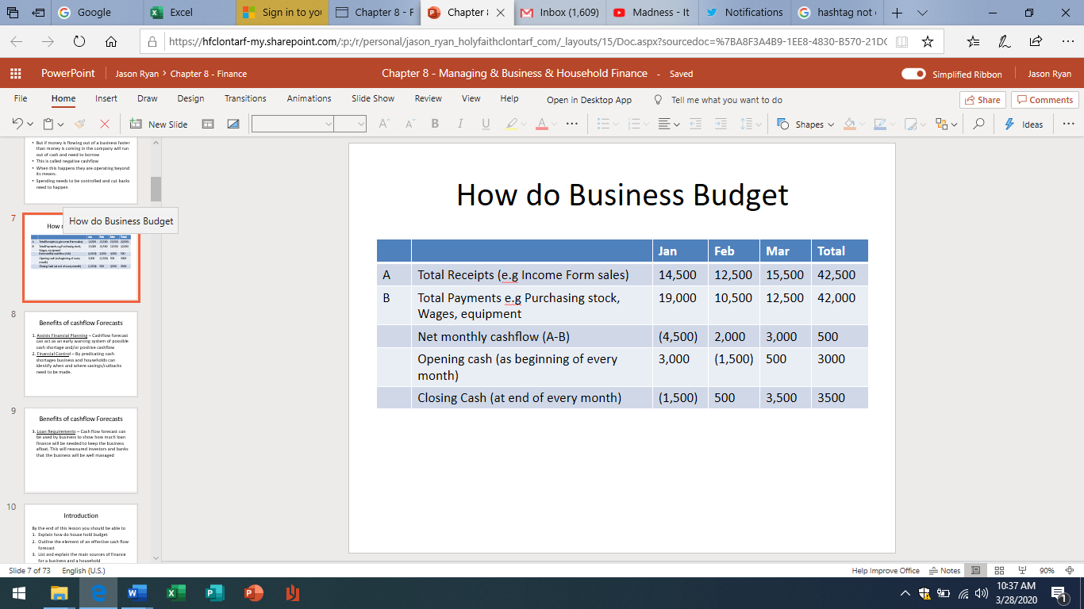

**Benefits of a cashflow statement**

1. Assists Financial Planning – Cashflow forecast can act as an early warning system of possible cash shortage and/or positive cashflow
2. Financial Control – By predicating cash shortages business and households can identify when and where savings/cutbacks need to be made.
3. Loan Requirements – Cash flow forecast can be used by business to show how much loan finance will be needed to keep the business afloat. This will reassure investors and banks that the business will be well managed

**Example of a simple cashflow forecast**

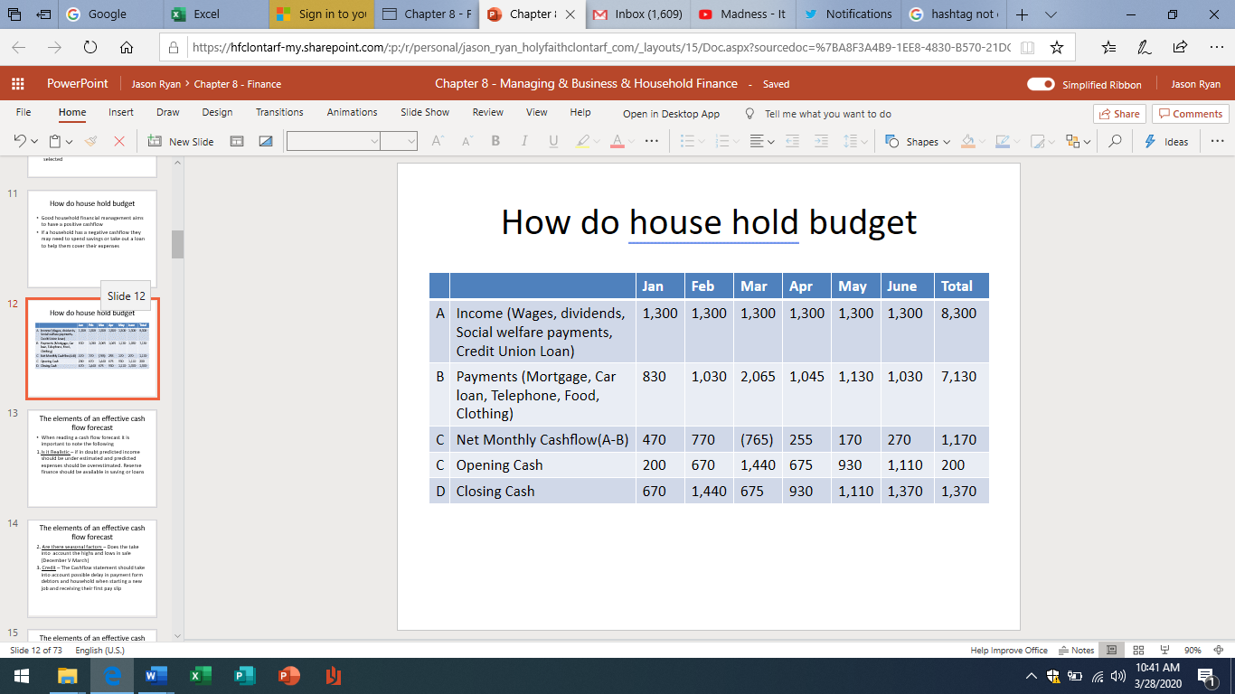

**Elements of an effective cashflow forecast**

1. Is it Realistic – if in doubt predicted income should be underestimated and predicted expenses should be overestimated? Reserve finance should be available in saving or loans
2. 2. Are there seasonal factors – Does the take into account the highs and lows in sales (December V March)
3. Credit – The Cashflow statement should take into account possible delay in payment form debtors and household when starting a new job and receiving their first pay slip
4. What about bad debts – These are debtors (people who owe the business money) who do not pay their bills. This is money lost to the business
5. Are taxes included

**Reading a cashflow forecast**

**E (Closing Cash)** This figure is got buy adding net cash figure and the opening cash figure (C + D) – The closing cash for the last month should be the same for the closing cash for the total

Remember

If there is a deficit (Minus figure) for a month – look back and see if there is a big payment for

that month or the previous month. If there is, one way to prevent this is to spread the payments

for that item over a few months instead of paying it all in one month

**Reading a cashflow forecast**

**A (Income)** This is any income received by the household and includes Wages, dividends, social welfare payment or loans. It is the money coming into the household (Income)

**B (Payments)** This is any expenditure paid by the household and includes Mortgage, car loan/service, telephone bill, food, entertainment, It is the money going out of the business (Expenditure)

**C (Net Monthly)** This is the difference between A and B. it is the money left over at the end of the month – A-B

**D (Opening Cash)** This is the money the household has at the start of the month, the closing cash for one month is the opening cash for the next month. Remember the same opening cash figure goes in Jan and Total

Source of Finance

**Short- term Source of finance**

|  |  |  |  |  |
| --- | --- | --- | --- | --- |
| **Trade Credit** | **Accrued Expenses** | **Bank Overdraft** | **Factoring Debt** | **Invoice Discounting** |
| This is receiving goods now but paying for them later  The business can use the money to pay bills that are urgent. To receive prompt payment suppliers offer discounts to business and charge interest for late payments | This is also known as unpaid expenses. It  means delaying payment of bills and using  the money to pay more urgent expenses  Businesses and households can delay paying bills (Gas, Electricity) until absolutely necessary and use this money to pay other bills. Households have to be careful that  they do not delay too much else they may  be cut off until the bills are paid | These are short term banks loans giving the current account holder permission to withdraw money gather than they actually have in their  current account. The maximum amount of the loan has to be agreed in advance with the bank | This means selling the right to collect payment from your debtors to a factoring (Debt collecting) firm | This is when a business gets a loan from a bank to the value of some percentage of the amount owed to the business by its customers |

**Main source of Finance**

The sources of finance available to a business and a household are

Short term Should be repaid within one year

Medium term Should be repaid within one to five years

Long Term Does not need to be repaid for at least 5 years

**How should finance be selected**

The following criteria should be taken in consideration when selecting a source of finance

1. Purpose - the source of finance should match the use for which it is needed

2. Amount – The source of finance should be able to provide the amount of finance required

3. Cost – Both should try to get the cheapest source of finance. APR (Annual Percentage Rate) is a standard measure of the interest charged on loans. Some source of finance are tax deductible

4. Control –

5. Risk -

**Medium - term Source of finance**

|  |  |  |
| --- | --- | --- |
| **Hire Purchase** | **Leasing** | **Term Loan** |
| This allows a household or business to buy an asset (car) by paying for it in instalments over a period of time  The asset can be used straight away but full ownership only passes when the item is paid for in full (last instalment) | This means renting an item (Car) for an agreed number of years. When the lease is up the item is returned to the lessor | This is a loan from a financial institution that is repaid in monthly installments over a number of years  The conditions of the loan differs on the needs of the household or business (Duration, interest charged, security required0 |

**What banks look for before giving a loan**

1. Amount a purpose for the loan

2. Creditworthiness of the person

3. Ability to repay the loan

4. Collateral

**How current account assists business and households**

1. Pay path system
2. Chequebooks
3. Standing orders
4. Direct debts
5. ATM cards
6. Debit Cards
7. Overdrafts

**Long - term Source of finance**

|  |  |  |  |  |
| --- | --- | --- | --- | --- |
| **Mortgage** | **Savings/Retained earning** | **Owners Capital/Equity** | **State Grant**  **Business** | **Invoice Discounting Business)** |
| These are loans used to finance the purchases of a house or other property  They are available form a bank or building society  A household/business will have to calculate the implication of the monthly repayments on their monthly cash flow before applying for a mortgage | Savings are a major source of finance for a household (Banks. Credit unions, An Post)  Deposit accounts pay savers interest on the money saved  The rate of interest will depend on the amount saved and how long it has been left on deposit  Retained earnings (reserves) a profit that have been retained (put back into the business) to allow the business to expand | This is finance brought into a business by the owner  This finance can be brought into the business through the entrepreneur’s personal finance, selling shares or bringing in a new partner | This is a free gift of money provided to a business to be used for a specific purpose  There are no interest or cash payments involved  But there are conditions that must be met and if they are not they money will have to be paid back | This is a contract to raise cash by selling a piece of property and then leasing it back on a long-term lease  This provide the business with a lump sum of money |